

A powerful 4-step program
That supports young people with eating disorders and BDD,
Ensuring that no child is left to struggle alone.

www.bodyimagecoach.co.uk
referrals: contact@bodyimagecoach.co.uk

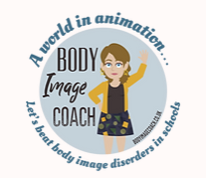




Welcome to our Body Image Coaching programme - an online service available worldwide that addresses eating disorders and body dysmorphic disorder through powerful animation videos and coaching.
OUR PROJECT

We understand the challenges parents and schools face with body image difficulties and eating disorders. Recognising the need for immediate and targeted support, we've developed a comprehensive solution.

The Problem

Since the pandemic, body image disorders have increased tenfold, with long NHS waiting lists and no early intervention for immediate support.



SOLUTIONS
We have developed an effective 4 step approach that seamlessly integrates healing without disrupting the curriculum or student attendance.

- All pupils aged 7 plus watch our free online body image awareness workshop. Through this animation workshop / session plan, we can identify those who are struggling with their body image, requiring support, we work with ages 11-25 and soon we will work with ages 7 plus.

- Easy Referral Process. Visit our website www.bodyimagecoach.co.uk and fill out the referral form, and we’ll guide you through safeguarding procedures before providing a short 15-minute induction to address any questions. After that, participants gain access to a 6-week online body image program, delivered individually. The program requires around 1–2 hours per week, including homework, and is supported by engaging animation workshops and optional peer support groups

- Additional support may be available through 1-1 coaching covering a range of comprehensive topics.

- If someone needs therapy, we are equipped to assist and offer 1-1 therapy sessions too.




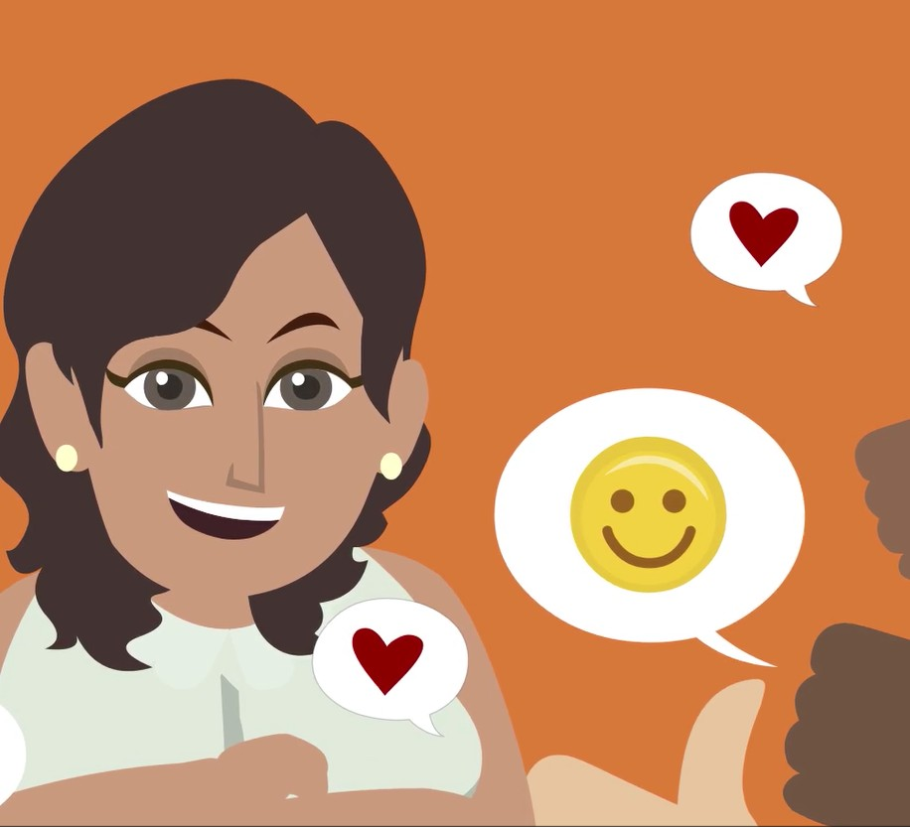

TESTIMONIALS

“I would absolutely recommend this. Pupils found the exercises invaluable, and it was great to see them talk about this topic with each other as a team.”

Loxford School Ilford

We've received excellent feedback from schools, parents, and teens we work with. Check out what people are saying here.


Our team is determined to help young people develop a positive body image and promote mental health; by providing them with the knowledge, tools and resources they need to navigate the challenges they face in today's society.
OBJECTIVES

Our team of mental health professionals provides early intervention services for secondary schools, providers and parents. Body Image Coach program can help you to take a proactive stance with our psycho- educational and coaching approach.

HOW OUR SYSTEM WORKS...

STEP 1
Head to the website for the awareness workshop @
www.bodyimagecoach.co.uk
Or skip this stage and make a referral.
STEP 2

Refer those that are struggling with their body image difficulties and set up an induction call.

STEP 3
Use our other on-line services:
-1-1 Coaching
-1-1 Therapy
-Peer support groups
-Therapy full day

OUR COMMITMENT


What sets us apart?

We focus on early intervention, using animation in psycho-educational workshops and coaching/therapy to deliver results. Instead of dwelling on the past, we educate you on how your brain works. Then, we tackle every barrier you're facing, raising awareness to make bold changes that promote healing.

Our results are visible in teens, often reaching them just in time before they hit a breaking point.

Explore our website for full-service details, team expertise, FAQs, free resources and more! See here.

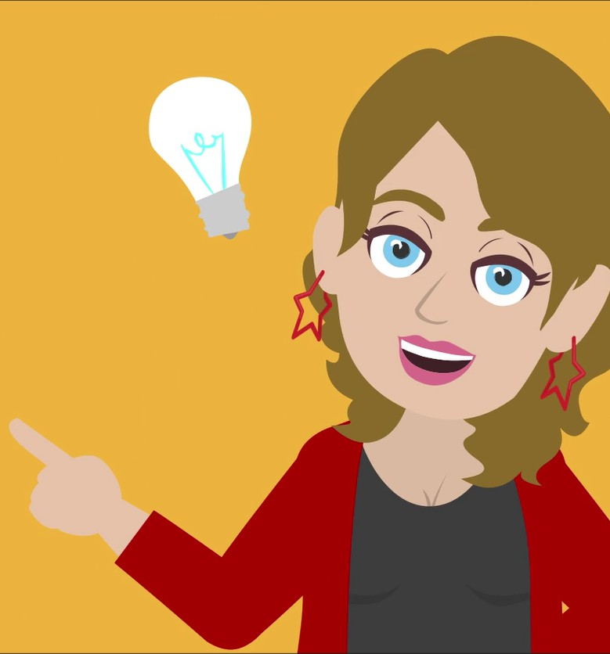

CONTACT US!
OLIVIA: HELLO@BODYIMAGECOACH.CO.UK 07984 380101
JANE: CONTACT@BODYIMAGECOACH.CO.UK

07944 930907
BODYIMAGECOACH.CO.UK

